Avontece Cabrera

SWDV 665

3/23/21

**Screen Shots**

I followed along the video tutorials to create the groceries app, update the about tab as well as adding groceries to a list, below are my tabs screenshots.

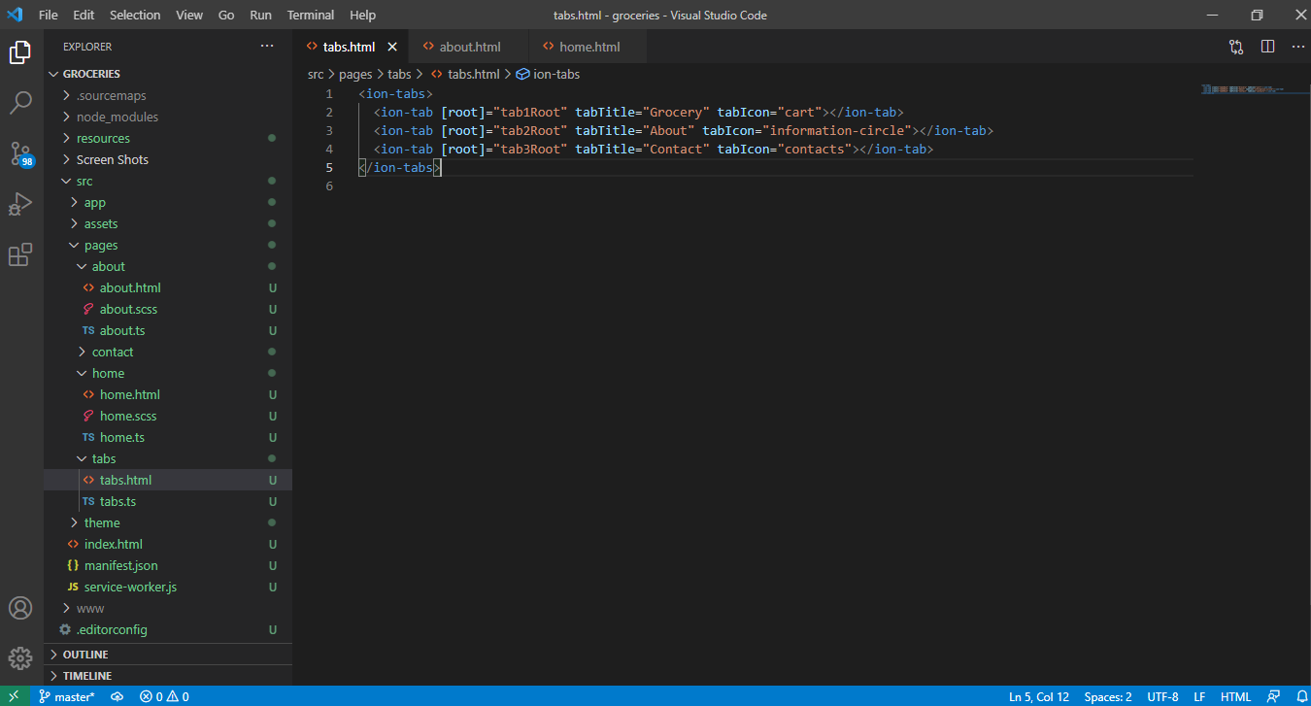

Updated the "About" tab with my full name and Student ID :

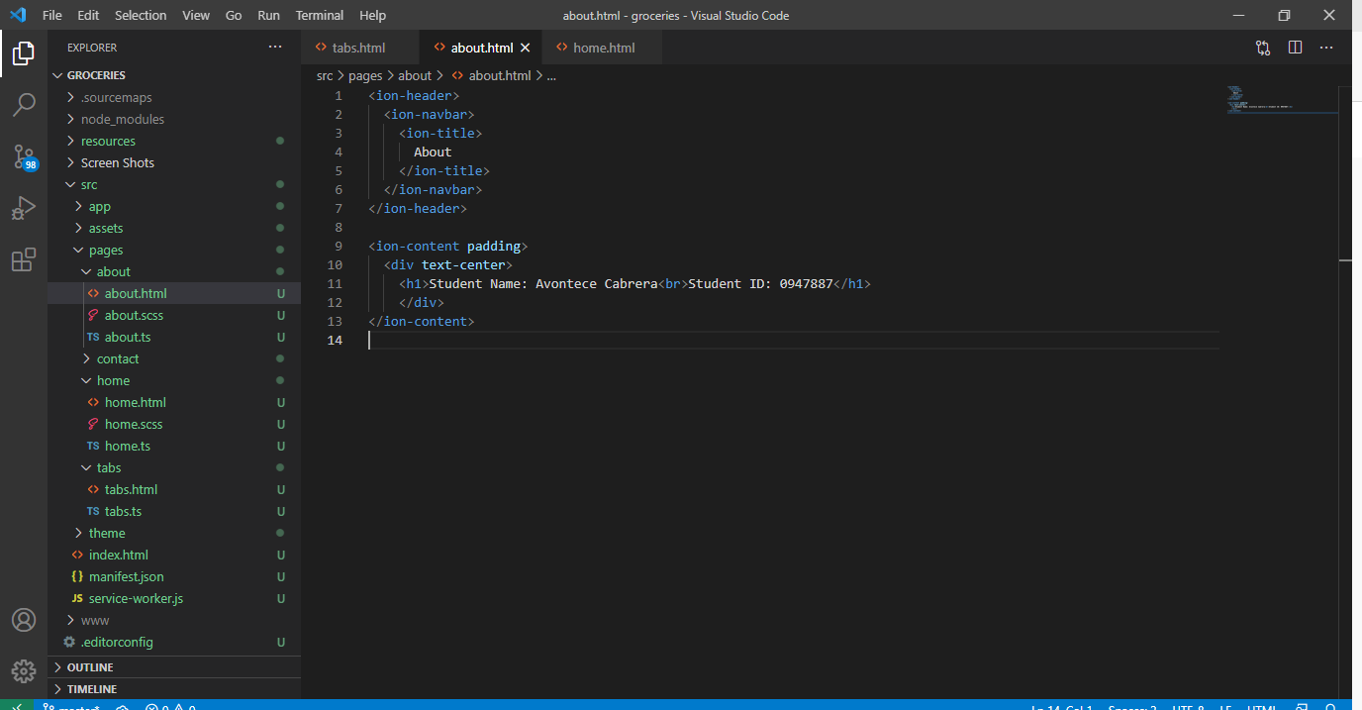

Updated the home page with the grocery items:

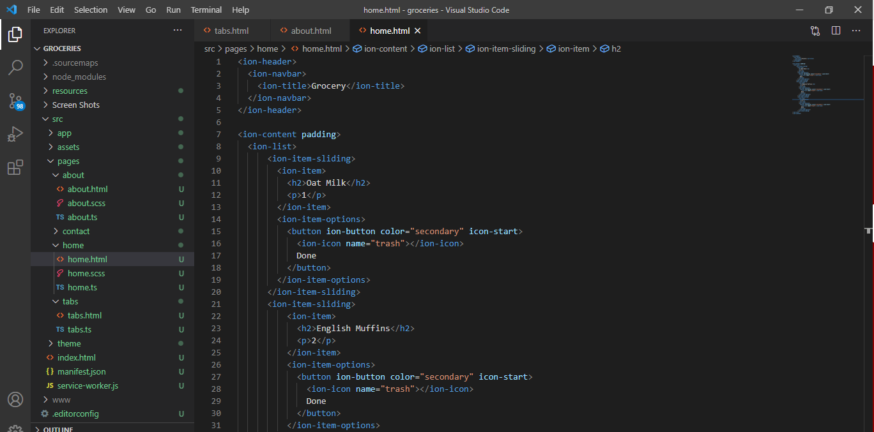

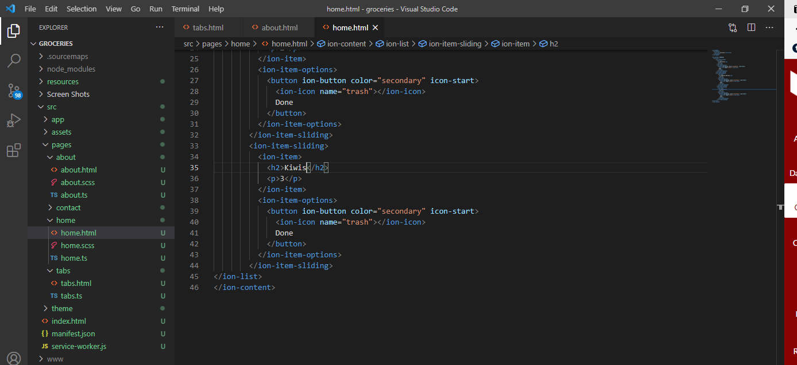

Below are the shots of the app with the updates :

